One question we often get from SLIM users is, “What’s the best way to deploy SLIM Suite tools in a distributed environment?” The answer to that depends to some extent upon how you intend to use the applications and the needs of your user community. SLIM applications can be installed in standalone mode (the local workstation install) or over a network (the network install). You can also have a parallel or hybrid configuration (i.e., users can run the tools over a network when at work, but use the standalone version when they are on the road).
There are advantages and drawbacks to each type of configuration:
Standalone mode: runs faster because workbook files are stored and opened locally. You also won’t have to worry about multiple users possibly overwriting each other’s changes in the same file: this can be a problem in a shared network environment. Though no two users can open and modify the same file at the same time, there is nothing to prevent User 1 from modifying a workbook just after User 2 saves changes to that file and closes it. Standalone installations are also more convenient for laptop users who travel frequently or work at home. Even with a VPN, users will generally find that SLIM Suite performs more snappily when the applications are installed locally.
Network installations are easier to maintain when it comes time to administer annual license updates or patches. For this reason alone, large corporations with many users may find a network configuration more suitable.
Hybrid or dual installations allow administrators to push upgrades out quickly while giving users the freedom to travel and work remotely or when no connection to the network is available.
A related question deals with file storage: where is the best place to keep various types of SLIM files? Again, it depends. The important considerations are:
- Who needs to edit or update the file?
- Who needs access to the file?
- Do they really need access to the original data (and do you really want multiple users updating it)? Or would it be better to have one person manage the file and make reports available to multiple users?
The following example may help you answer these questions.
Clients and new users often express a desire to centralize their corporate DataManager repository and allow distributed users to add projects to it remotely at will. They believe unrestricted data entry will help their data repository grow swiftly and allow the entire enterprise to benefit from immediate access to new data. Unfortunately, allowing universal access and data entry does not promote (and may degrade) the accuracy and integrity of your corporate database.
Newly submitted project data is rarely accurate and complete in its first iteration. At the end of a project, it is not at all uncommon for project managers to enter the best information they have at the time. They fully intend to update partial or incorrect data once better information becomes available. In a perfect world, such users would mark such projects clearly to prevent third parties from using it in queries, benchmarks, or to calibrate new estimates. But in the real world, people are frequently interrupted. They get distracted by other work, or a new project takes priority over completing the project closeout.
Busy people make mistakes. They procrastinate or are transferred to new jobs, leaving their unfinished work to someone who is untrained, inexperienced, or even unaware of its existence!
For all these reasons, QSM strongly advises our clients to appoint a database administrator to validate all incoming project data. Requiring users to submit their data to a central administrator for inspection and validation against a uniform corporate standard is a best practice that cannot be violated without risking the integrity of the data. Once incoming projects have been examined and validated, the database administrator can publish periodic updates to the central repository. This method lessens the risk that incomplete or inaccurate data will be used for validating estimates and benchmarking. As each new database update is published, the database administrator should ask all users to replace any local copies of the database with the newest version.
Though we recommend providing distributed users with an officially published and validated corporate repository, smaller, specialized databases can reside on local machines for individual use in estimation support or benchmarking analysis. These databases can easily be created via the query and database export features on the File menu in SLIM-Metrics.
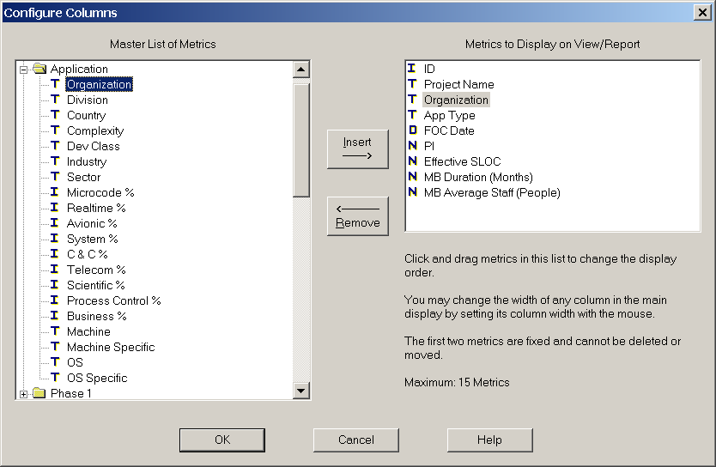
Users who don’t have a SLIM-Metrics license can create subsets of their master database manually via the Project View Layout feature in DataManager. The method is suitable for simple queries that combine conditions using an “and” condition (for example, you want a database of all projects from a specified organization completed after a specified cutoff date). The list of columns and fields is fully customizable – just insert the desired metrics from the Master List into the Metrics to Display on View/Report window. Up to 15 metrics can be displayed at a time.
The resulting columns will then appear on the Project List view in DataManager.
In this example I will use one of our sample files (SW-MetricsDemo.smp) to show how it’s done. First you should save your database using a new name. You want to select all projects completed by Binary Systems after January 1st, 2005. The first step is to sort the Organization column (just click the column heading) so the Binary Systems projects are grouped together:
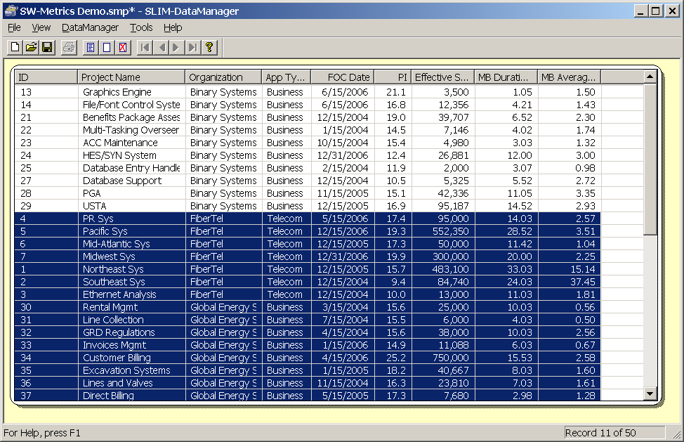
Click on the first record you want to delete and shift/click the last record, then click the Delete Project(s) button in the toolbar. Next, can sort the FOC Date column or simply ctrl/click any projects that completed before January 1st of 2005 and hit the delete button.
More complex queries are best handled in SLIM-Metrics, but this method is fine for simple sorting jobs or whenever you want to create a smaller, specialized database using a fairly simple set of selection criteria.
As you can see, SLIM Suite is designed to provide you with flexible deployment and analysis options. If you have questions or would like to discuss any of these topics in more depth, please don’t hesitate to contact a QSM support representative.

